2020 Summer Newsletter

10599 Twin Lake Rd. NE Mancelona, MI 49659

Phone (231)587-8354 Fax (231)587-4066

www.bluelaketwpkalkaska.org

Township Hall Office Hours

Supervisor: Thurs 1:00 PM – 4:00 PM
Sat 10:00 AM – Noon
Clerk: Tues 9:00 AM – 3:00 PM
Treasurer: Wed 10:00 AM – 1:00 PM
Assessor: 2nd & 4th Tue. 9:00 AM – Noon
Zoning Dept: Fri & Sat 10:00 AM – Noon

Fire Dept. Meeting: Mon 7:00 PM

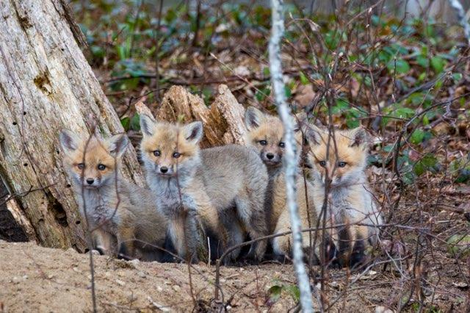

Township Telephone Numbers you may need: Emergency Call 911

Supervisor | Blair Shearer | Home: 231-587-5698 | blsuper@torchlake.com
Clerk | Tracy Nichol | Home: 231-587-9644 | blclerk@torchlake.com
Treasurer | Christine Almose | Home: 231-587-9593 | bltreas@torchlake.com
Trustee | Mary Shaw | Home :231-587-8468 | maryshaw@torchlake.com
Trustee | Larry Shoemaker | Home: 231-587-0723 | Gladysshoemaker90@yahoo.com
Township Assessor | David Grimm | Home: 231-331-6370 | blasser@torchlake.com
Zoning Admin | Kathy Campbell | Home: 231-384-6147 | blzoning@torchlake.com
Blue Lake Fire Dept. | Chief Greg Brierley | Home: 734-216-9137 | bluelakefirechief@att.net

 | Phone Number | Other County Numbers of Interest: | Phone Number
American Waste (Trash) | 231-258-9030 | Kalkaska County Road Comm. | 231-258-2242
Kalkaska County  Comm. Kohn Fisher | 231-258-5178 | Kalkaska Animal Control | 231-258-3309
Kalkaska Sheriff Department | 231-258-8686 | DNR Burning Permit  http://www.dnr.state.mi.us.burnpermits | 866-922-2876
Kalkaska County Clerk | 231-258-3300 | EGLE (formally DEQ)  Theresa Sherwood | 989-619-3740
Kalkaska Recycle Center | 231-384-1304 | RAP Poaching Hotline | 800-292-7800

Township Meetings
The Township Board meets the first Wednesday of every month at 7:00 PM at the township Hall.
The Planning Commission meets the first Wednesday of every month at 9:00 AM at the township Hall.
The Fire Department meets every Monday evening at 7 PM at the fire barn located on Blue Lake Road.
COVID-19, CDC guidelines will apply to all meetings.

Doing Business A Little Differently due to COVID-19
We still want to answer your questions, get your garbage stickers for you, take your absentee ballots, and help you in any other way we can. But we are doing things a little differently. When you come to the township hall you will find signs on the doors. We are keeping the door to the offices locked. We have the door to the meeting room open. If you come into the meeting room you will see a sign asking, “How can I help you?” There is a bell to ring to get our attention and a sign in sheet for your name and number. There will be a Plexiglas panel between us. We are trying to limit the personal contact exposure for you and ourselves. We have masks available if you need one and plenty of hand sanitizer.

Fire Department
Please do not call the fire station phone number for an emergency. Our fire and rescue department is dispatched by calling 911. The Fire Dept. is actively seeking new members. If you are interested, they meet at 7:00 PM every Monday at the Fire Barn located on Blue Lake Rd. just north of Blue Lake. They will be glad to show you around and give you details about joining the Department. You can also contact our Fire Chief Greg Brierley at 734-216- 9137.

Bob Barr resigned as chief effective May 6, 2020. Don’t worry, this has been in the works for a while and Bob is now serving as a Captain on the Fire Department. You will still have the same dedication, compassion, and service you have come to expect from Bob answering your 911 calls for the last 25 plus years. We are grateful he will remain on the department and will continue to serve our community.

Greg Brierley has been the Chief-in-training since last fall. He was appointed Chief on May 6, 2020. He comes to us with 30 years of firefighting experience and a broad range of competencies from fire science to HAZMAT and Medical. Greg has been on the department for several years serving Blue Lake Township on a part-time basis. We welcome him as the new fire chief.

Burn Permits
Please add the following web site to your phone/computer to gain information on whether it is legal to burn:
www.2.dnr.state.mi.us/burnpermits. The website is continuously updated. If you touch the County of Kalkaska on the map of Michigan, it will show each township in the county and if burning is authorized. Sometimes burning is only allowed at special times of the day. You can only burn the following: leaves, grass, limbs, brush, stumps, and evergreen needles. No building materials, plastic, rubber, foam, chemical treated wood, textiles, electronics, chemicals, or hazardous materials may be burned. Notice to those who choose to burn: You are responsible for fire, smoke, or odors created from open burning…. And for damage that results from your fire. It is a citable offense if you are not in attendance during the burn. It is also a citable offense if you are burning without a permit.

Wave Boats/High Water
ATTENTION BOATERS! With lake levels at all-time highs, please be courteous of the erosion caused to our shorelines, seawalls, and homes from high speed boat wake action.

DNR watercraft rules require that boating activity stay a minimum of 100 feet away from stationary structures “i.e.: docks, swim rafts or shorelines”. Please travel counterclockwise around lake.
The DNR boat launch on Big Twin Lake is CLOSED due to high water levels until further notice.

Eagle and North Crooked Lake – Slow, no wake.
Bass, Indian, Little Twin, North Blue and Squaw lakes – No high-speed boating or water skiing or towing. Boats and Pontoons should go slowly with minimum wake.
Big Twin, Big Blue, Starvation Lakes – No high-speed boating between 7:30PM – 11:00AM

In the Michigan laws and responsibilities boating handbook, section 324.80158 states the owner of any vessel operated upon the waters of this state is personally responsible for any damage to life or property resulting from a wake or swell created by the negligent operation or propulsion of the vessel, if the vessel is being operated with his or her consent.
Any property damage should be reported to the Kalkaska Sheriff department.

From the Clerk’s Desk
August 4th is our Primary Election and November 3rd is our General Election. We will have in person voting. Our polls will be open from 7:00 AM until 8:00 PM. If you would like an absentee ballot for any reason please contact the Clerk (231.587.8354 or blclerk@torchlake.com and the “Request for Absentee Ballot” will be mailed to you. You may also go to our website www.bluelaketwpkalkaska.org under Departments and Service, Elections and print one off. You mail email it, drop it in our drop box or mail it back.

Drop Box
The Township has a Secure Drop Box located between the office and Hall doors. For your convenience this can be used to drop off any correspondence (for example: voter information or taxes).

From the Treasurer’s Desk
Due to COVID-19 and limiting personal contact, we have included with your tax bill an envelope to mail your tax payments into us. Tear off the top portion of your bill, be sure Blue Lake Township address shows through the window, include your check, add a stamp and mail, or place it in the drop box. We will mail you a receipt.

In case you are wondering, envelopes cost us 0.03 cents each. We contract with a service to mail your tax bills and the newsletters out to you. For those of you who own multiple properties, there is no way to sort and mail your tax bills in one envelope. We do get a discounted mail rate. When the County of Kalkaska printed our bills for us, we used to sort them by hand. Now it is all done by computer and machines.

Your summer tax bill is due by Monday, September 14, 2020. We will be open from 10:00 AM – 1:00 PM on that Monday to receive payments thru the drop box. We will also be receiving payments through the mail that are postmarked by 9-14-2020. Any payments after that will be late and penalty will be applied.

Trash Pickup
Residential trash pickup is on Monday by American Waste with a 5-bag limit per household. If a holiday falls on Monday, pickup will be on Tuesday. Please do not put out trash that is not bagged - our contract with American is for bagged trash only. If you put your trash out before Monday morning, please have your trash in an animal proof receptacle. Dogs, cats, ravens, and raccoons are just some of the critters who love to spread trash around. FYI: scattered trash violates the nuisance ordinance and a ticket may be issued. Appliance Recycling - Ready to upgrade or get rid of an old refrigerator or freezer? Call Energy Optimization at 877-296-4319 to schedule an appointment to pick your old working refrigerator or freezer. You can also receive a $50.00 cash incentive for having purchased your new energy star appliance. If your old refrigerator or freezer is no longer working, you can call American waste for pick up at 231-258-9030. However, they will not pick up your old appliance unless the Freon has been removed and has a sticker documenting the removal. According to American Waste the closest company that deals with Freon removal is B & T electric in Traverse City at 231-947-0465.

Zoning Permits
A Zoning Permit shall not be issued until all other necessary permits required by federal, state, county or local regulations, including well and septic system approvals have been obtained or waived with exception of those permits issued by the Kalkaska County Building Department and County soil erosion, sedimentation and storm water runoff control office. The location of the property boundaries and all structures shall be staked on the ground for Zoning Administrator approval prior to the issuance of the Zoning Permit.

Zoning Department Complaint Form
To provide better service, the Zoning Department has developed a complaint form. This form is available on our web site on the “Zoning and Permits” page and should be used for all complaints about possible violations of our Zoning Ordinance. Once received the Zoning Administrator will investigate and take any action that is required. No alterations to the original form will be accepted.

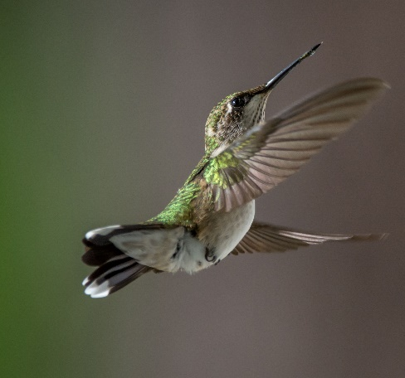
Community Police Officer
Ben Hawkins is our Community Officer and has been providing regular road patrol within the Township. If you have a concern or an issue you would like to discuss with Deputy Hawkins, you can leave a detailed message for him at the Sheriff’s office at 231-258-8686. For any emergency always call 911. In an emergency other Sheriff’s Department Officers may respond.

Land Splits & Divisions
All land divisions, new lot lines, and lot combinations must comply with Blue Lake Township Ordinances and the State Land Division Act. There are requirements as to road access, the size and shape of the lots, and the number of lots that can be created. An application and more information are available on the web site under “Zoning and Permits”. An application fee of $50 and a $20 per split administration fee is required. Your completed application and fees must be submitted to the Blue Lake Township Land Division Agent, the Assessor, David Grimm.

Enjoy Your Summer!

Short Term Rental Property
The Zoning Ordinance requires short term rental properties be registered with the Township. It also requires that owners post an information sheet in a conspicuous location within the property. If you rent out your property, please contact the Zoning Administrator.

Campers and Trailers
Per our Township Zoning Ordinance Campers and Trailers cannot be stored or left on vacant property. This helps keep vandalism down, improves property values, and prevents that abandoned look. Campers can be used for 15 days in a 12-month period without a permit. Upon application to the Township Zoning Administrator, a permit costing $5.00 will be issued for an additional 30 days. A Camper may be kept on any property that has a dwelling without a permit.

Township Hall Available
The Township Hall is available for your personal use. It requires an application to be completed and a $50 deposit. If the usage rules are followed and the hall is left clean, the deposit will be refunded. Call the hall at 231-587-8354 during office hours or visit our web site and look under “Events - Hall Rental” for further information

Broadband Service
The Township maintains a Public Access Wi-Fi system at the Township Hall. If you have a compatible computer, you can use it in and around the Township Hall to access the Internet. It works in the parking lot but if you are there during office hours come in and use the table inside.

County Recycle Center
The County Recycle center is located at 904 Island Lake Road. Hours are Monday-Thursday from 8:00 AM – 4:30 PM and Saturday 8:00 AM – Noon. Call 231-384-1304 for tire information.

Kalkaska Public Transit Authority
Starting January 1, 2020 all Kalkaska County Residents 60 years of age and older will ride free of charge on all KPTA buses. This Senior Ride Free program is provided through a contract between Kalkaska Public Transit Authority and Kalkaska County Commission on Aging. Currently the service is for transportation within Kalkaska County only and does not apply to trips going into Grand Traverse County. If anyone would like additional information regarding this service, please feel free to contact KPTA at 231-258-6808 or the COA at 231-258-5030.

Land Values in Blue Lake for 2020
1 Acre | $4,500 |  | Bass Lake | $300 FF
1.5 Acre | $6,750 |  | Big Twin Lake | $2,150 FF
5 Acre | $13,500 |  | Little Twin Lake | $830 FF
10 Acre | $21,000 |  | North Blue Lake | $1,000FF
20 Acre | $36,000 |  | Eagle Lake | $350 FF
40 Acre | $64,000 |  | Big Blue Lake | $1,430 FF
50Acre | $77,000 |  | South Blue Lake | $260 FF
100 Acre | $140,000 |  | Crooked Lake N & S | $275 FF
 |  |  | Indian Lake | $350 FF
 |  |  | Squaw Lake | $350 FF
 |  |  | Starvation Lake | $1,025 FF
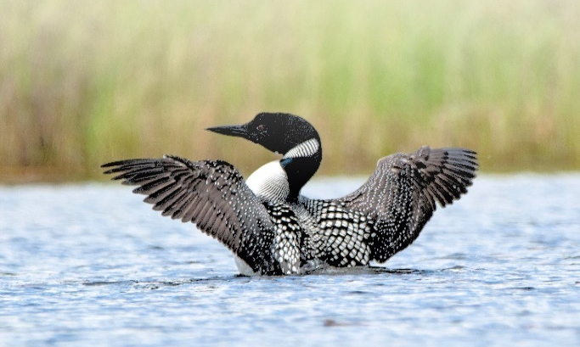
(Photos courtesy of Susan George)

Visit our website www.bluelaketwpkalkaska.org for more township information!

