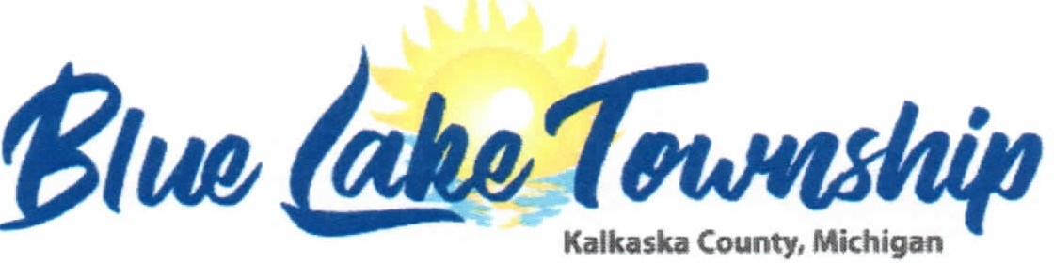

10599 Twin Lake Rd. NE Mancelona Ml 49659 Phone (231)587-8354 Fax (231)587-4066
www.bluelaketwpkalkaska.org

AGENDA
SPECIAL TOWNSHIP MEETING
For the purpose: discussion of Fire Chief’s Weekly Hours
Thursday, July 21, 2022 at 3:00 PM

- Meeting Call to Order/Pledge of Allegiance - Shearer
- Roll Call of Officers - Nichol
- Adoption of Agenda - Shearer
- Discussion of Fire Chief’s Weekly Hours
- Public Input
- Adjournment

